CHAPTER 4: RESULTS AND DISCUSSION

4.1 Introduction
This chapter presented the model evaluation, application tests and interface results. It examined the frozen V4 classifier, behavioural-domain errors and integration workflows, then assessed the five Chapter 1 objectives against the available evidence.
The frozen V4 XGBoost pipeline transformed forty semantic features into forty-two estimator columns and used threshold 0.50. Its reported performance came from synthetic development data. Labels represented suspicious-pattern scenarios; model predictions, independent rule findings and human investigation outcomes remained distinct.

4.2 Evaluation Procedures and Evidence Boundaries

4.2.1 Model Evaluation Population
The retained synthetic benchmark design specified 100,000 scored transactions and 24,000 separate warm-up events across four populations. Development used 60,000 scored training transactions and 15,000 scored validation transactions, supported by 14,400 and 3,600 warm-up events respectively. Training and validation used disjoint wallet and agent populations. Warm-up events provided prior observable history and were not added to the denominators of scored classification metrics. The labels represented the union of twelve defined suspicious-pattern families across structuring, wallet-network and agent behaviour.
The retained training labels comprised 47,770 normal and 12,230 suspicious-pattern observations; validation comprised 11,970 normal and 3,030 suspicious-pattern observations. Thus the two disclosed development populations contained 75,000 scored events, of which 15,260 were union-positive. The remaining 25,000 scored events belonged to the retained 15,000-row final-test and 10,000-row independent-evaluation populations. Their results were not available as accepted V4 tests. The 2,000 wallets and 160 agents described the complete synthetic design, while the disclosed training and validation populations used 1,200/96 and 300/24 wallets/agents respectively. A design total was not used to infer undisclosed held-out class counts.
The twelve families had unequal, overlapping membership. The earlier claim of 88,000 normal records, 12,000 suspicious records and exactly 1,000 examples per family did not describe V4. Validation prevalence was 20.2%, reflecting the constructed sample rather than operational prevalence. Entity isolation, reset history state and exact row/label alignment passed the frozen matrix audit.
Table 4.1: Populations used in the recorded V4 development evaluation
Population | Scored transactions | Warm-up events | Wallets / agents | Use
Training | 60,000 | 14,400 | 1,200 / 96 | Fit only; 47,770 normal / 12,230 positive
Development validation | 15,000 | 3,600 | 300 / 24 | Selection/diagnosis; 11,970 normal / 3,030 positive
Other retained partitions | 25,000 | 6,000 | Separate retained populations | No accepted independent V4 result; private class counts not inferred
Validation was excluded from fitting but reused for model selection and feature diagnostics. It therefore remained development validation, not an untouched test. Synthetic performance did not establish effectiveness on an operational mobile-money provider's data.

4.2.2 Recorded Model Testing Procedure
Evaluation checked the causal feature contract, fitted preprocessing on training data only, generated validation probabilities at the fixed 0.50 threshold, and saved classification and ranking metrics for comparison. Entity identifiers, application scores and label provenance were excluded from predictors. All candidates followed this procedure; no retraining was performed for this chapter.
The following extract documents the retained metric procedure in ml_v4/development_training/run_stage18.py; its results were saved in ml_v4/evidence/stage18/primary_XGB_metrics.json.
predicted = probability >= 0.50
tn, fp, fn, tp = confusion_matrix(
actual, predicted, labels=[0, 1]).ravel()
precision = precision_score(actual, predicted, zero_division=0)
recall = recall_score(actual, predicted, zero_division=0)
macro_f1 = f1_score(actual, predicted, average="macro",
zero_division=0)
false_positive_rate = fp / (fp + tn)
roc_auc = roc_auc_score(actual, probability)
average_precision = average_precision_score(actual, probability)
Precision measured the proportion of positive predictions that matched synthetic suspicious labels; recall measured the proportion of synthetic suspicious examples detected. Macro F1 gave equal weight to the normal and suspicious classes, while the false-positive rate used the normal-class denominator. ROC-AUC assessed probability ranking across thresholds, and average precision summarised precision-recall performance. Average precision is reported by its actual name and is not relabelled as a separately calculated trapezoidal precision-recall area. Class imbalance and dependence among transactions required these measures to be interpreted together [3].
Balanced accuracy averaged normal and suspicious recalls. Precision depended on the constructed positive prevalence and was not directly transferable to an operational population.

4.2.3 Application and Demonstration Procedures
Application verification examined access permissions, payment identity, history attestation, inference failures, private event routing and message receipts. Financial safety used disposable databases and mocked failures; local application inspection was read-only. These checks did not establish live-transfer performance, sustained throughput or panel execution times.
Table 4.2: Functional verification procedure and required evidence
Process | Procedure | Evidence or acceptance condition
Payment and inference | Commit once; verify newly captured history; complete V4; repeat the same request identity | One payment identity; reconciled balances; one recorded analysis result
Failure and retry | Introduce a verification or inference failure in a disposable ledger | Committed payment retained; explicit error; audited nonfinancial retry
Access control | Compare anonymous, customer, compliance and administrator requests | Only authorised pages, private rooms and alert information accessible
Customer history | Retrieve outgoing and incoming transactions across history pages | Every expected transaction appears exactly once with recorded status
Messaging | Send, acknowledge delivery and open the matching authorised thread | Persistent history and correct sent, delivered and read transitions
Redis delivery | Observe a private event through a second authorised broker instance | Correct local recipient; no event leakage to unrelated users
Panel timing | Use a stopwatch and retain the same transaction or message identity across views | Actual elapsed time recorded against Chapter 1 limits

4.2.4 Feature, Temporal and Source-History Checks
The feature audit distinguished the semantic feature contract from the estimator input matrix. Forty semantic fields did not imply forty numerical columns: deterministic expansion of the transaction-type field produced forty-two ordered estimator columns. The retained training and validation matrices therefore had shapes $60,000 × 42$ and $15,000 × 42$. The input verification checked transaction identity, order, label alignment and family-union consistency. Identifier alignment was used to associate evidence with observations; the identifiers themselves were not admitted as predictor columns.
Missing-history handling was field-specific. The saved preprocessing specification converted only declared sentinel markers to missing values, retained valid negative measurements, and applied a training-fitted median imputer and standard scaling. Empty imputation columns used the declared fallback, while the retained full pipeline added no separate missingness indicators. This avoided the inaccurate statement that every raw historical field was initially complete. The relevant requirement was that the frozen preprocessing contract handled permitted missing-history states consistently without fitting new statistics from validation or application traffic.
Temporal verification used the deterministic key comprising the UTC event timestamp and unique integer transaction identifier. Prior history admitted only smaller keys, including smaller identifiers when timestamps were identical. The extractor emitted the feature row before adding the event to persistent historical state. Fields defined as recent activity could combine the eligible prior events with the known current event exactly once; those declarations were distinguished from prior-only baselines and path histories. The current amount and type were legitimate attributes of the assessed payment. No field could obtain information from a larger key, a later outcome or another population. Canonical capture established source completeness, while the feature rules enforced their own causal cutoff within that source.
Saved-array verification checked confusion arithmetic, macro F1 and family denominators. Artifact hashes and feature-order checks supported reproducibility. These were technical consistency checks within the development environment, not an external audit or independent evaluation.
Table 4.3: Recorded feature and temporal verification results
Check | Expected result | Recorded result | Status
F01: schema and order | Forty named semantic fields; forty-two ordered estimator columns | Schema, exact label/order joins and full preprocessing parity passed | PASS
F02: current event | Emit before historical update; include current once only where declared | Hand calculations for wallet, network and service roles matched | PASS
F03: future and ties | Ignore greater keys; deterministic equal-time ordering | Future append, same-time keys and duplicate rejection checks passed | PASS
F04: population isolation | No shared wallet/agent identifiers or carried history | Matrix entity-isolation audit and reset fixtures passed | PASS
F05: labels and application risk | No truth, private provenance, rule scores or predictions as inputs | Observable-only interface and private-field rejection passed | PASS
F06: agent aggregation | Use correct serviced wallet, direction and time boundaries | Hand-computed agent primitives, returning customers and cash exclusions matched | PASS
F07: cold start | Apply declared markers and eligibility; do not invent history | All-forty-field cold-start and age/support boundary fixtures passed | PASS
F08: numerical safety | Distinguish declared missing markers from valid signed values | Marker-aware schema checks and preprocessing parity passed; legitimate missing history retained | PASS

Table 4.3 summarises fixture, leakage, temporal and missing-history checks. Suite totals are reported together in Section 4.4.8.

4.2.5 Separate Test-Set Requirement and Outstanding Evidence
The departmental guide required a model test dataset separate from both training and validation. No accepted V4 evaluation meeting that requirement was present in the reviewed evidence. The existing final-test and independent-evaluation populations were retained under controlled access, but their public eligibility certificates marked the support check as failed and prohibited their use as accepted tests. This meant that the documented coverage requirements were not certified; the public record did not disclose the private counts or exact failed conditions. The chapters therefore did not guess those details, open the populations or attribute older model results to them.
Independent test custody was also not established. Model approval, functional checks and reused validation scores did not replace an independently controlled test population.
Completion of that requirement would need an eligible independently controlled population, verified entity separation and support, followed by separately authorised evaluation of the same hash-verified pipeline at threshold 0.50. The record would retain the scored size, class and family denominators, confusion matrix, precision, recall, F1, false-positive rate and probability-ranking measures. Neither preprocessing nor the model could be fitted to the test observations, and the operating threshold could not be selected from the results. This review did not execute that evaluation. The source records were the public held-out eligibility certificate, boundary-verification record, custody-readiness decision and frozen development card.

4.3 Frozen V4 Development Results

4.3.1 Candidate Comparison and Selection
Logistic Regression, Random Forest, HistGradientBoosting and XGBoost were compared using the same declared representation and development partitions. The predeclared selection rule considered eligible candidates within a macro-F1 tolerance of 0.005 and preferred the lower false-positive rate within that group. XGBoost was selected under that rule. HistGradientBoosting produced the highest observed macro F1, so the selection cannot correctly be described as choosing the largest macro F1 alone.
Logistic Regression provided a linear baseline, Random Forest a bagged-tree comparison, and HistGradientBoosting and XGBoost nonlinear boosted-tree alternatives. All used identical development partitions, train-fitted preprocessing and threshold 0.50. Logistic Regression failed the suspicious/domain-recall eligibility checks; the other candidates passed. Eligibility also required macro F1, controlled false-positive rates and technical stability.
Table 4.4: Synthetic validation candidate comparison at threshold 0.50
Candidate | Macro F1 | Suspicious recall | False-positive rate
Logistic Regression | 0.8105 | 0.5977 | 0.0357
Random Forest | 0.9461 | 0.8825 | 0.0127
HistGradientBoosting | 0.9616 | 0.9248 | 0.0116
V4 XGBoost | 0.9567 | 0.9036 | 0.0099
The macro-F1 difference between HistGradientBoosting (0.961632) and XGBoost (0.956670) was 0.004961, within the 0.005 tolerance. XGBoost reduced false positives from 139 to 118, but increased false negatives from 228 to 292. Selection followed the declared false-positive preference, not superiority across all metrics; statistical significance was not established.

4.3.2 Classification Metrics and Confusion Matrix
Table 4.5: Frozen V4 results on the 15,000-row synthetic validation set
Metric | Recorded result
Accuracy | 0.972667
Balanced accuracy | 0.946886
Macro F1 | 0.956670
Suspicious precision | 0.958683
Suspicious recall | 0.903630
Suspicious F1 | 0.930343
Normal recall | 0.990142
False-positive rate | 0.009858
ROC-AUC | 0.996046
Average precision | 0.985972
Brier score | 0.020140
There were 11,970 normal and 3,030 suspicious-labelled validation observations. The confusion counts were 11,852 true negatives, 118 false positives, 292 false negatives and 2,738 true positives. The counts sum to 15,000 and produce accuracy of $\frac{14,590}{15,000} ≈ 0.972667$. Suspicious precision was $\frac{2,738}{2,856} ≈ 0.958683$ and recall was $\frac{2,738}{3,030} ≈ 0.903630$. These denominators make clear that high accuracy coexisted with 292 missed benchmark-positive examples.
Table 4.6: Frozen V4 synthetic validation confusion counts
Actual label | Predicted normal | Predicted suspicious | Total
Normal | 11,852 (TN) | 118 (FP) | 11,970
Suspicious pattern | 292 (FN) | 2,738 (TP) | 3,030
Total | 12,144 | 2,856 | 15,000

Source: recorded frozen V4 synthetic Validation confusion counts, primary_XGB_metrics.json. This figure reports development Validation rather than an independent test.
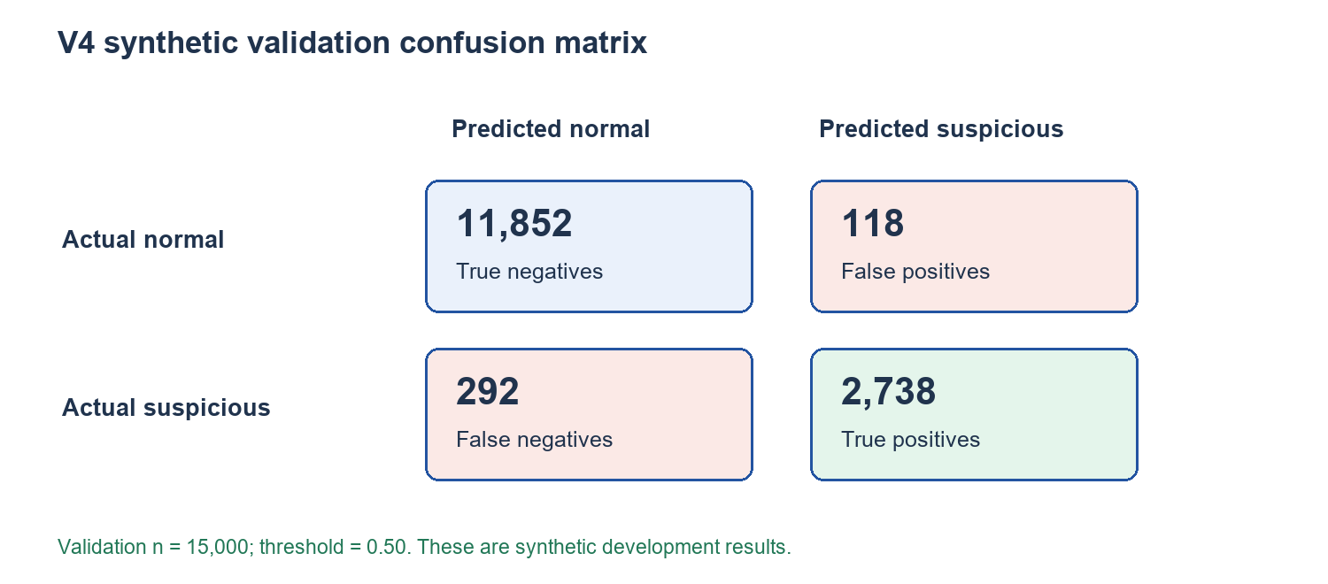
Figure 4.1: Frozen V4 synthetic validation confusion matrix
The 0.99% false-positive rate applied to this synthetic validation distribution. Operational alert ratios could differ because of independent rules, rapid repeated activity and pending analysis. Precision also depended on the sample's 20.2% positive prevalence.

4.3.3 Behavioural-Domain and Family Results
Table 4.7: Overlapping suspicious-domain detection on synthetic validation
Domain | Detected / support | Recall
Structuring | $$\frac{600}{684}$$ | 0.8772
Wallet-network | $$\frac{675}{776}$$ | 0.8698
Agent | $$\frac{1,831}{1,941}$$ | 0.9433
The classifier predicted one union target. Overlapping domain and family counts could not be added, and a flagged multi-family example did not demonstrate separate recognition of each behaviour.
Table 4.8: Frozen V4 synthetic validation family diagnostics
Family | Detected / support | Recall | Validation support objective
S1 | $$\frac{126}{132}$$ | 0.9545 | Below 300 examples
S2 | $$\frac{11}{23}$$ | 0.4783 | Below 300 examples
S3 | $$\frac{492}{546}$$ | 0.9011 | Met
S4 | $$\frac{4}{16}$$ | 0.2500 | Below 300 examples
N1 | $$\frac{77}{101}$$ | 0.7624 | Below 300 examples
N2 | $$\frac{381}{429}$$ | 0.8881 | Met
N3 | $$\frac{122}{130}$$ | 0.9385 | Below 300 examples
N4 | $$\frac{123}{144}$$ | 0.8542 | Below 300 examples
A1 | $$\frac{1,467}{1,467}$$ | 1.0000 | Met
A2 | $$\frac{109}{148}$$ | 0.7365 | Below 300 examples
A3 | $$\frac{255}{255}$$ | 1.0000 | Below 300 examples
A4 | $$\frac{151}{222}$$ | 0.6802 | Below 300 examples
The strongest observed family results included A1 at $\frac{1,467}{1,467}$, A3 at $\frac{255}{255}$, S1 at $\frac{126}{132}$ and N3 at $\frac{122}{130}$. These observations were specific to the reused development cohort. A1 contributed a large proportion of positive examples and the frozen card recorded substantial dependence on agent-growth information. Strong A1 performance could therefore influence aggregate recall while concealing smaller families that remained difficult.
S2 detected 11/23 examples across seven subjects and clusters; S4 detected 4/16. All four S4 detections overlapped other families, leaving S4-only detection at 0/12. Nine family-support objectives were unmet. Aggregate performance therefore concealed sparse, weakly detected patterns.

4.3.4 Retained Pipeline and Fixed Decision Threshold
Table 4.9 records the retained original XGBoost pipeline. Its fitted preprocessing, ordered columns and classifier were preserved together; later exploratory representations did not replace it.
Table 4.9: Retained V4 XGBoost pipeline configuration
Component | Frozen specification
Semantic / estimator dimensions | 40 fields / 42 ordered numerical columns
Classifier objective | binary:logistic
Number of estimators | 200
Learning rate / maximum depth | 0.07 / 5
Minimum child weight | 5
Subsample / column sample | 1 / 1
Tree method / workers | hist / 1
Random state | 2026092915
Decision threshold | 0.50
Preprocessing fit population | Training only; retained imputation and scaling state
Selection status | Original development candidate retained; later exploratory alternatives not promoted
Threshold 0.50 was fixed before candidate fitting: probabilities at or above it produced suspicious predictions. No validation threshold sweep or target alert-ratio adjustment was performed. This boundary was distinct from scenario monetary bands and regulatory criteria; independent rules could flag model-normal payments.
$$ŷ = \left\{\begin{aligned}1 (suspicious pattern), if p ≥ 0.50 \\ 0 (normal), if p < 0.50\end{aligned}\right.$$

4.3.5 Error Implications, ROC-AUC and Precision–Recall Evidence
The 118 false positives could increase review work; the 292 false negatives represented missed benchmark patterns. Neither count measured proven laundering. Actual workload would depend on alert grouping, account repetition and analyst practice.
Figure 4.2 reconstructs ROC and precision-recall curves from retained validation arrays, with the frozen 0.50 operating point marked. ROC-AUC was 0.996046 and average precision 0.985972 against prevalence 0.202. Average precision was not a separately calculated trapezoidal area. No inference or retraining was performed.
Source: retained primary XGBoost validation probabilities and matching 15,000 validation labels; with matching observation identities and reproducible metric arithmetic. No new inference was performed.
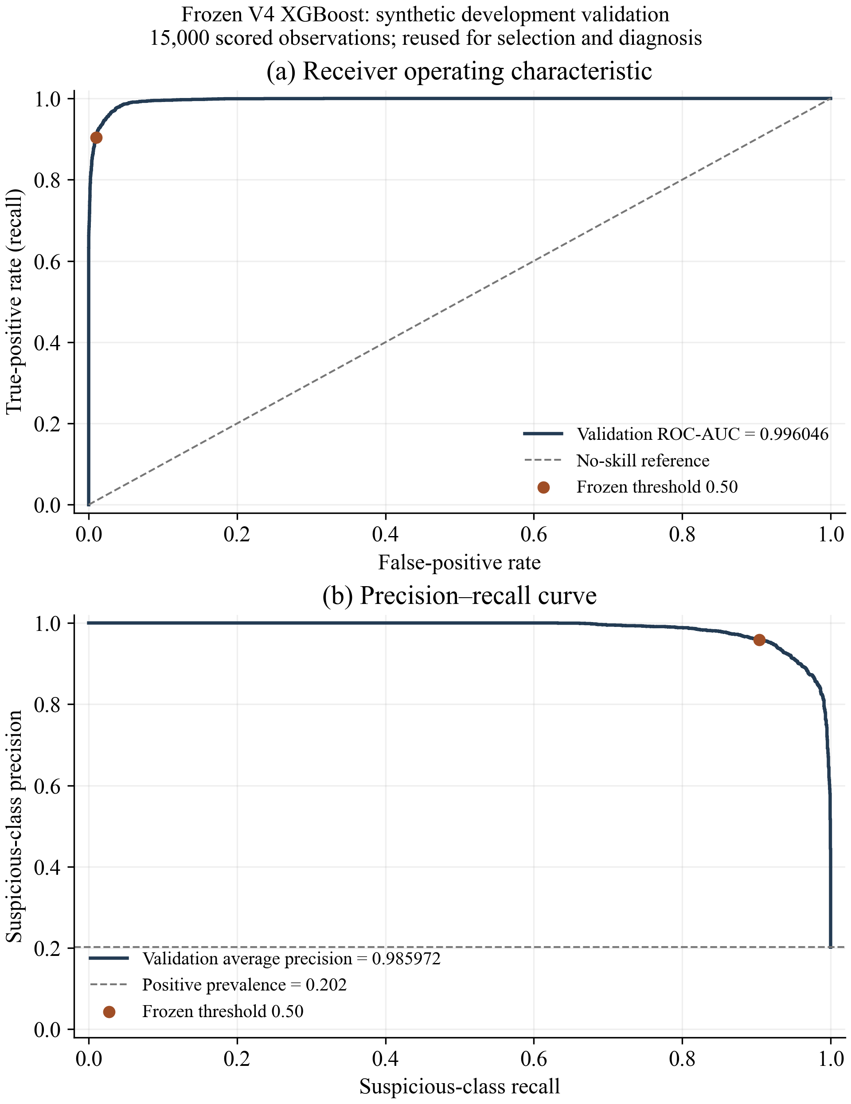
Figure 4.2: Frozen V4 validation ROC and precision–recall curves
Probability calibration was considered separately from ranking. The Brier score was 0.020140 and log loss was 0.073056 on validation. The saved calibration bins in Table 4.10 showed that the mean probability and observed positive proportion were not identical, particularly around the operating boundary. For example, the 0.50–0.60 bin had a mean probability of approximately 0.5509 and an observed synthetic-positive proportion of 0.7107. These descriptive differences did not justify refitting or recalibrating the frozen pipeline during application integration.
Table 4.10: Selected recorded probability-calibration bins on validation
Probability bin | Observations | Mean probability | Observed positive proportion
0.0–0.1 | 11,263 | 0.0134 | 0.0024
0.3–0.4 | 180 | 0.3501 | 0.4000
0.4–0.5 | 152 | 0.4483 | 0.5329
0.5–0.6 | 159 | 0.5509 | 0.7107
0.6–0.7 | 136 | 0.6513 | 0.7941
0.9–1.0 | 2,150 | 0.9856 | 0.9949
Calibration depended on the synthetic prevalence and histories, not the probability of proven laundering. Displays therefore retained the predicted class: confidence in a normal prediction was not suspicious-class probability.

4.3.6 Structuring Results and Representational Limits
Structuring-domain recall was $\frac{600}{684}$, or approximately 87.72%, but that aggregate covered overlapping family memberships. The contrast between S1 at $\frac{126}{132}$ and S3 at $\frac{492}{546}$, compared with S2 at $\frac{11}{23}$ and S4 at $\frac{4}{16}$, showed that a domain average alone was insufficient. Structuring features described prior counts, similar amounts, activity acceleration, active hours and near-band activity. The presence of such fields demonstrated representational coverage; it did not guarantee that every intended predicate was recoverable from the representation.
S4-only detection at 0/12 showed a weakness obscured by overlapping detections. Sparse subjects made family rates unstable; stronger conclusions required sufficient independent subjects rather than repeated analysis of the same examples.
The representation audit identified possible information limits: S2?s similar-amount count and share did not generally reconstruct the exact cluster value or historical frequency, while S4 lacked complete distinct-amount and historical near-band information. Some unnamed quantities could nevertheless be reconstructed from other primitives. These findings motivated investigation; they did not establish the cause of individual misses or guarantee that added fields would repair detection.

4.3.7 Wallet-Network and Agent Results
Wallet-network recall was $\frac{675}{776}$, or approximately 86.98%. Family results ranged from N1 at $\frac{77}{101}$ to N3 at $\frac{122}{130}$, with N2 at $\frac{381}{429}$ and N4 at $\frac{123}{144}$. The representation included inbound and outbound counts, distinct counterparties, accelerations, prior return-path information and pass-through measures. These features supported analysis of relationships extending beyond the current payment amount. However, the frozen evidence also recorded information loss associated with the selected route, so the tabular summary was not a complete reconstruction of all network paths.
Agent-domain recall was $\frac{1,831}{1,941}$, or approximately 94.33%. A1 and A3 were detected completely in the observed validation sample, whereas A2 recall was $\frac{109}{148}$ and A4 recall was $\frac{151}{222}$. Agent primitives included wallet growth, new-wallet share, concentration, service acceleration and cash-in/cash-out measures. The disparity demonstrated that high performance on one form of agent activity could not establish reliable detection of every agent pattern. Legitimate differences in service location, customer demand and liquidity would also require representative evaluation before an operational claim could be made.
Aggregate recall ranked agent first, structuring second and wallet-network third. Structuring 600/684 slightly exceeded network 675/776; S2 and S4 remained specific weaknesses. No matched graph-versus-tabular evaluation or individual feature-attribution study was conducted.
Operational agent quantities also vary with legitimate demand, location, liquidity and seasonality. Representative evaluation and investigation outcomes would be needed to interpret those patterns beyond this synthetic benchmark.

4.3.8 Controlled Representation Experiment and Freeze Decision
The exploratory forty-four-feature XGBoost increased validation true positives from 2,738 to 2,751 and reduced false positives from 118 to 115. Macro F1 rose by 0.001744 and recall by 0.004290. S2 improved, but S4 remained at 4/16, S4-only at 0/12, and A4 lost seven detections. HistGradientBoosting macro F1 decreased from approximately 0.961632 to 0.961164. The changes therefore did not establish a uniform improvement.
Table 4.11: Exploratory representation comparison on reused validation
Representation / model | Macro F1 | Positive recall | False-positive rate | Structuring recall
40-field-XGB | 0.956670 | 0.903630 | 0.009858 | 0.877193
44-field-XGB | 0.958415 | 0.907921 | 0.009607 | 0.891813
40-field-HGB | 0.961632 | 0.924752 | 0.011612 | 0.885965
44-field-HGB | 0.961164 | 0.922442 | 0.011362 | 0.891813

The four experimental fields described similar-amount cluster value, prior similar-amount frequency, distinct recent near-band amounts and prior near-band frequency. Their definitions and eligibility appear in Chapter 3. The comparison used forty versus forty-four semantic features (forty-two versus forty-six encoded columns), not the older thirty-versus-thirty-four-feature architecture.
All comparisons reused development validation after diagnosis informed the hypothesis. Sparse support and mixed results prevented a statistically confirmed improvement claim. No held-out population was opened, new model fitted for this chapter or expanded model promoted into the application.
The original forty-field pipeline remained primary. The later hypothesis arose from validation inspection and had no fresh independent confirmation; exploratory alternatives were not promoted.

4.4 Application Integration and Interface Results

4.4.1 Recorded Local Review and Financial Safety
A previously recorded read-only application review identified the local MySQL database as aml, the authenticated principal as aml@127.0.0.1 and the server UUID as d441b7bb-43f6-11f1-a2d8-0a0027000005. That historical review observed 8,402 transactions, 20 users and 627 alerts, with canonical history marked COMPLETE_VERIFIED and an unchanged before/after protected-record fingerprint. These are recorded observations from that review, not a current live database inventory or the model evaluation population.
Payments and captures committed before V4 analysis. The authorised verifier refreshed the new source revision, and inference rejected stale revisions. Idempotent requests and audited nonfinancial retries preserved the committed payment when analysis failed.
V4 was selected through AML_PRIMARY_MODEL=V4 while independent rules remained enabled through AML_RULE_ENGINE_ENABLED=ON. Under that configuration, the customer route selected the V4 branch before the superseded Stage14 branch and did not silently fall back when V4 failed. The frozen artifact, feature order and threshold remained separate from application rule settings. A successful startup alone was insufficient evidence of a particular payment inference; a transaction-specific saved result was the required evidence for that payment.
The revised operational score assigned 70% weight to V4 suspicious-probability risk and 30% to the independent rule score:
$$R = round\left(0.70 × \left(100p\right) + 0.30r, 2\right)$$
where p was the frozen model's suspicious-class probability and r was the rule score on the 0-100 scale. Selected-class confidence was not substituted for suspicious probability. The numerical index had no additional minimum floor. Review status was assessed separately and retained the highest applicable weighted-score band, independent rule band or suspicious V4 decision. Independent findings could therefore require review even when the weighted index was lower. The frozen classification threshold remained 0.50.
On 19 October 2026, thirty-eight nonfinancial checks passed for shared primary/retry scoring, personal-amount integration and dashboard metadata. Alert updates preserved case status, assignment and notes. Failed inference retained explicit error and rule-only scoring. The policy applied to newly completed decisions without recalculating historical scores; these checks were not a model evaluation or live latency benchmark.
The 70/30 scoring weights combined risk inputs; the generator's 70/30 mix described scenario intentions. Neither prescribed the model's prediction ratio.
On 19 October 2026, a further read-only application review observed 22 users, 14,002 transactions, 646 alerts and 29 messages in the same verified local database. The screenshots in Figures 4.3–4.6 and 4.8 were rendered through the actual Flask routes using these stored records. Before-and-after fingerprints matched for users, transactions, alerts, messages and canonical mobile-money events. Live sockets and all browser write requests were disabled during capture. These images therefore document stored state and interface presentation, rather than a new payment, investigation disposition, message exchange or latency benchmark.

4.4.2 Customer Transaction History
The customer dashboard provided recent transactions and access to earlier history in pages of twenty-five records. Incoming transfers were included when the customer wallet was the receiver, alongside outgoing payments where it was the sender. Each record exposed the transaction identity, time, type, amount, counterparty and stored analysis status. The display mapped normal and low operational levels to Normal, suspicious to Suspicious, and higher review levels to Super suspicious. Pending or failed inference remained distinguishable and was not converted into a normal prediction.
A disposable 27-record case appeared across two pages exactly once with separate AI/rule reasons. Panel review required matching account and transaction identities across customer and compliance views.
Source: actual customer transaction-history interface rendered from local MySQL records under enforced read-only access, 19 October 2026. Transaction 15222 belongs to wallet ACC1011.
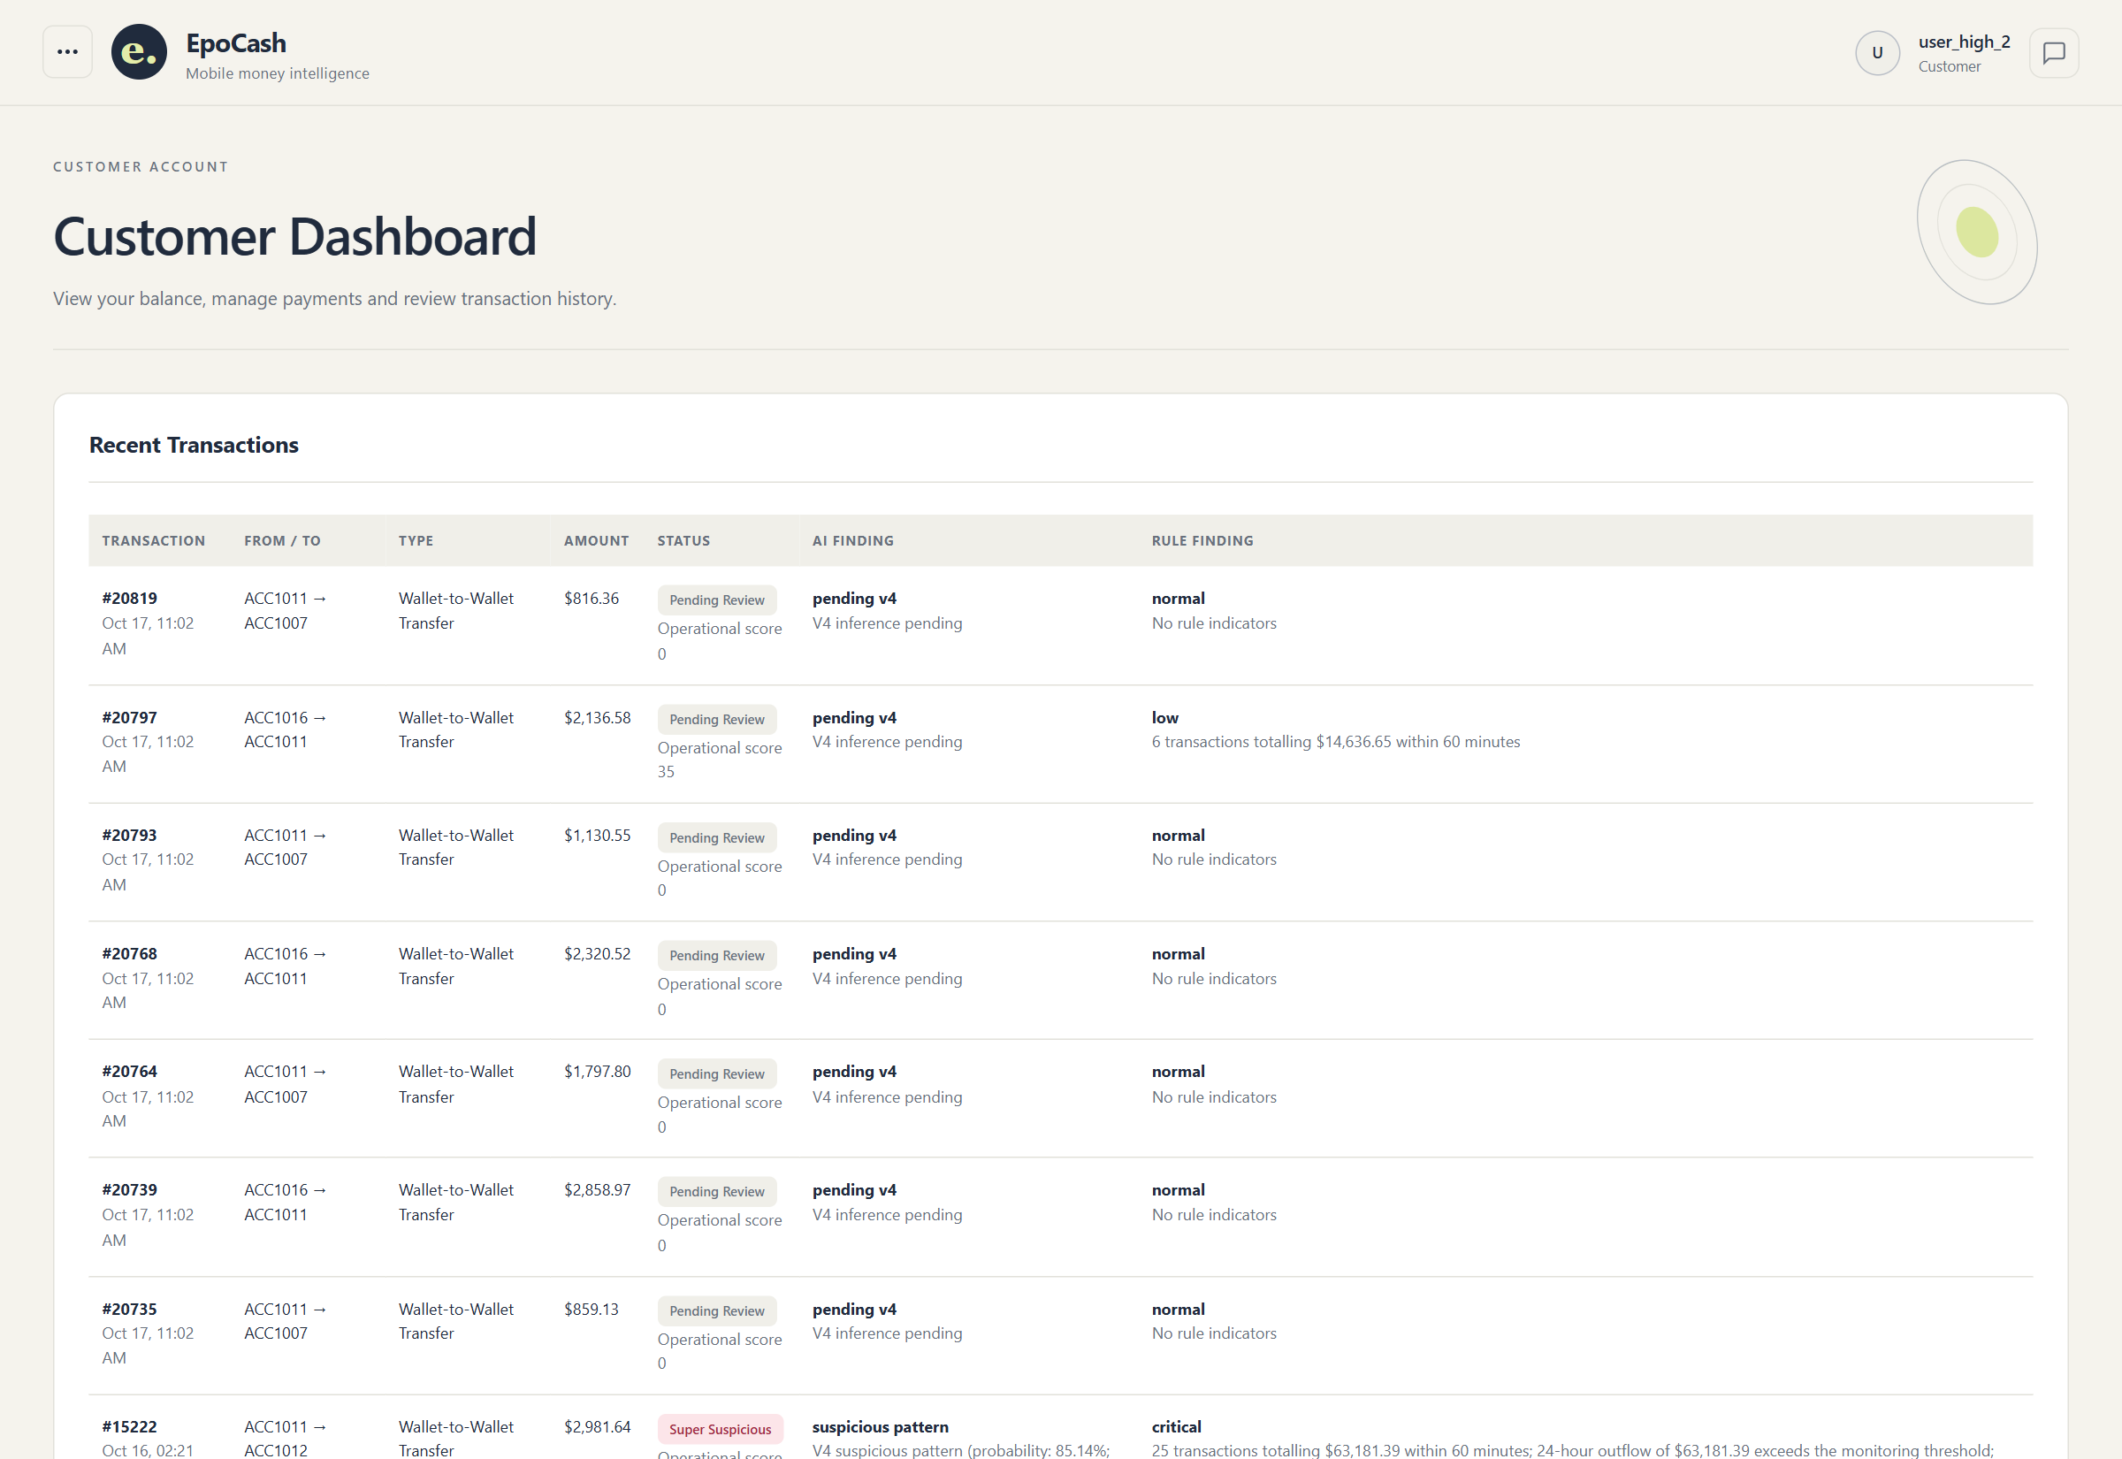

Figure 4.3: Customer recent transaction history(transaction details followed by AI and rule findings)

4.4.3 Compliance Review and Separate Findings
Compliance review linked the payment, recorded V4 result, independent rule findings and investigation state. Missing legacy reasoning remained explicit. The officer retained responsibility for the investigation outcome.
Saved V4 probability, rule findings and historical indicators were distinct evidence. No validated transaction-specific SHAP or equivalent attribution was reported; a displayed history indicator was not proof of its contribution to the model output.
The read-only review returned successful customer, administrator, compliance, report and messaging pages. Anonymous sockets were rejected and customer sessions excluded from staff rooms. Sampled 1,440-pixel and 390-pixel views had no JavaScript exceptions or horizontal overflow. This supported the checked routes and layouts, not universal accessibility or device compatibility.
Source: actual compliance review for alert 6900 and transaction 15222, rendered read-only on 19 October 2026. The recorded score and separate AI and rule findings were retained.


Figure 4.4: V4 compliance alert with separate AI and rule findings(alert and AI detail followed by rule findings)

4.4.4 Messaging, Receipts and Real-Time Updates
Messages persisted before delivery. Sent, delivered and read receipts represented server storage, receipt by the intended client and opening of the thread. Tests rejected unrelated-user acknowledgements and verified single, double grey and double blue ticks beside the timestamp. Conversations remained available after reopening.
The communication policy permitted customer-to-customer and customer-to-compliance conversations, together with compliance-to-administrator communication. Direct customer-to-administrator communication was blocked in both directions through the shared authorisation policy. Search and contact displays included the person’s username and account identity. These restrictions applied to message history, sending, acknowledgements and private attachments, rather than relying only on which contacts the interface displayed.
Redis relayed events across instances while MySQL retained authoritative history. Device notifications required permission and an authenticated open page receiving the socket event; the service worker displayed that notification. Delivery after every application page closed was not established [17], [18].
Source: actual stored customer-compliance conversation rendered read-only on 19 October 2026. No message was sent and no delivered/read receipt was changed during capture.
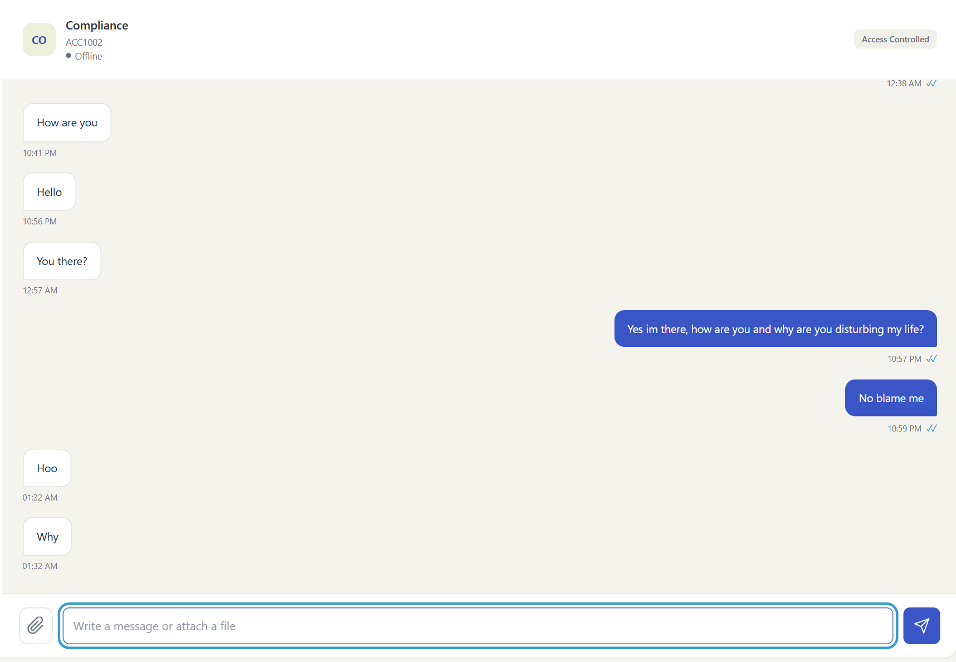
Figure 4.5: Authenticated messaging interface

4.4.5 Transaction Generation and Demonstration Evidence
The transaction generation module used the payment and canonical-history path, selecting eligible existing customer wallets. Qualifying recent outgoing activity informed routine amounts and counterparties; fewer than five observations indicated limited history. Generation retained current timestamps rather than fabricating elapsed historical activity.
The 70% routine and 30% suspicious mix specified inputs, not forced predictions. Rapid batches could trigger velocity rules, and V4 could miss suspicious scenarios. Saved, normal, suspicious, pending and error counts separated payment completion from analysis completion.
Source: actual administrator generation interface and observed customer baselines, captured read-only on 19 October 2026. Seven routine and three suspicious scenario inputs were selected; this image does not report a submitted or completed batch.
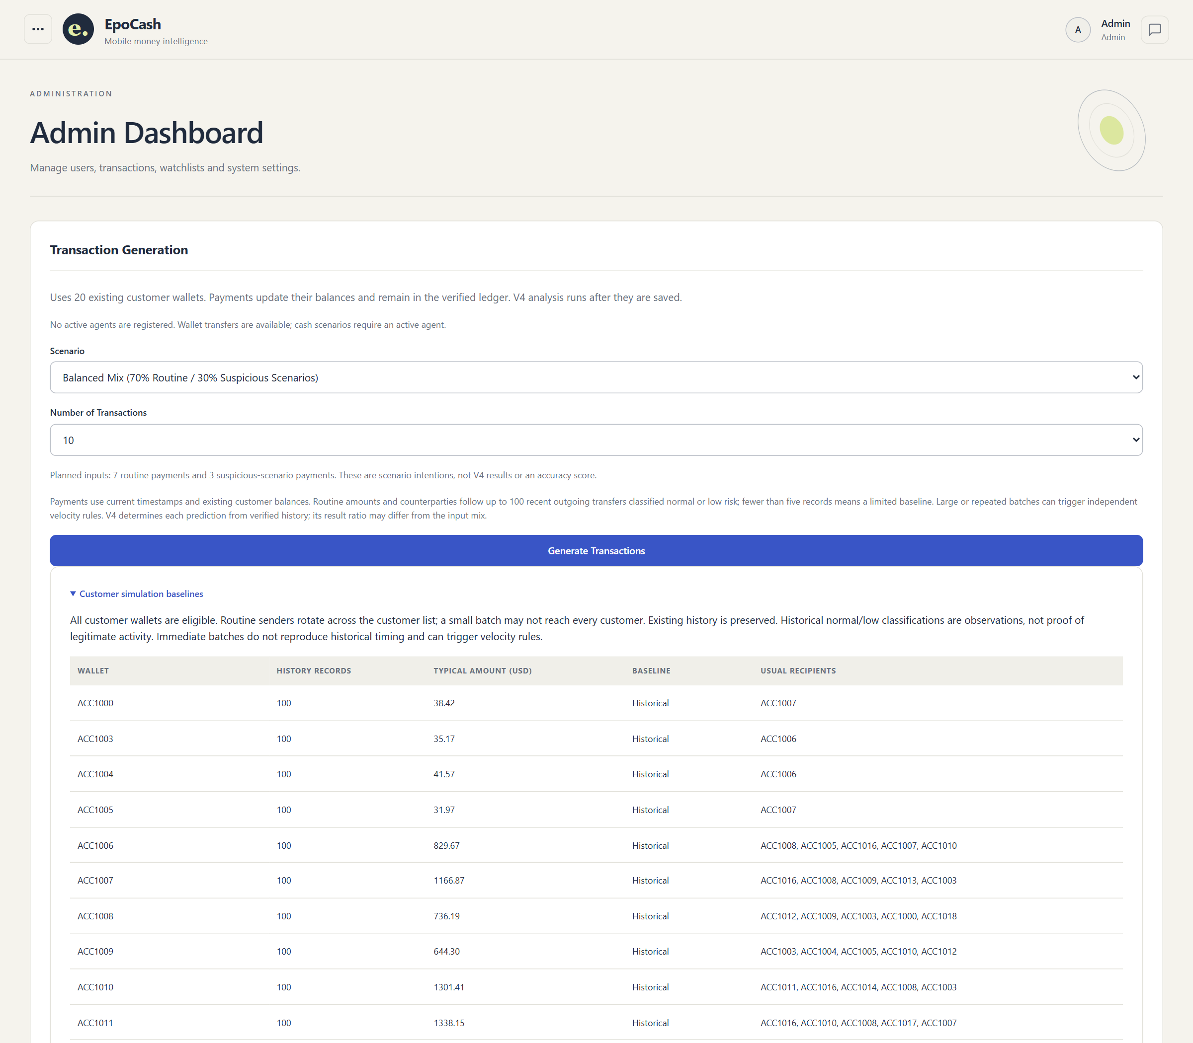

Figure 4.6: Transaction generation configuration and observed customer baselines(configuration followed by a baseline excerpt)
Source: isolated Redis/Socket.IO routing probe, 19 October 2026. Two temporary Flask application instances in one Python process used actual Redis and Socket.IO test clients on a private test channel.
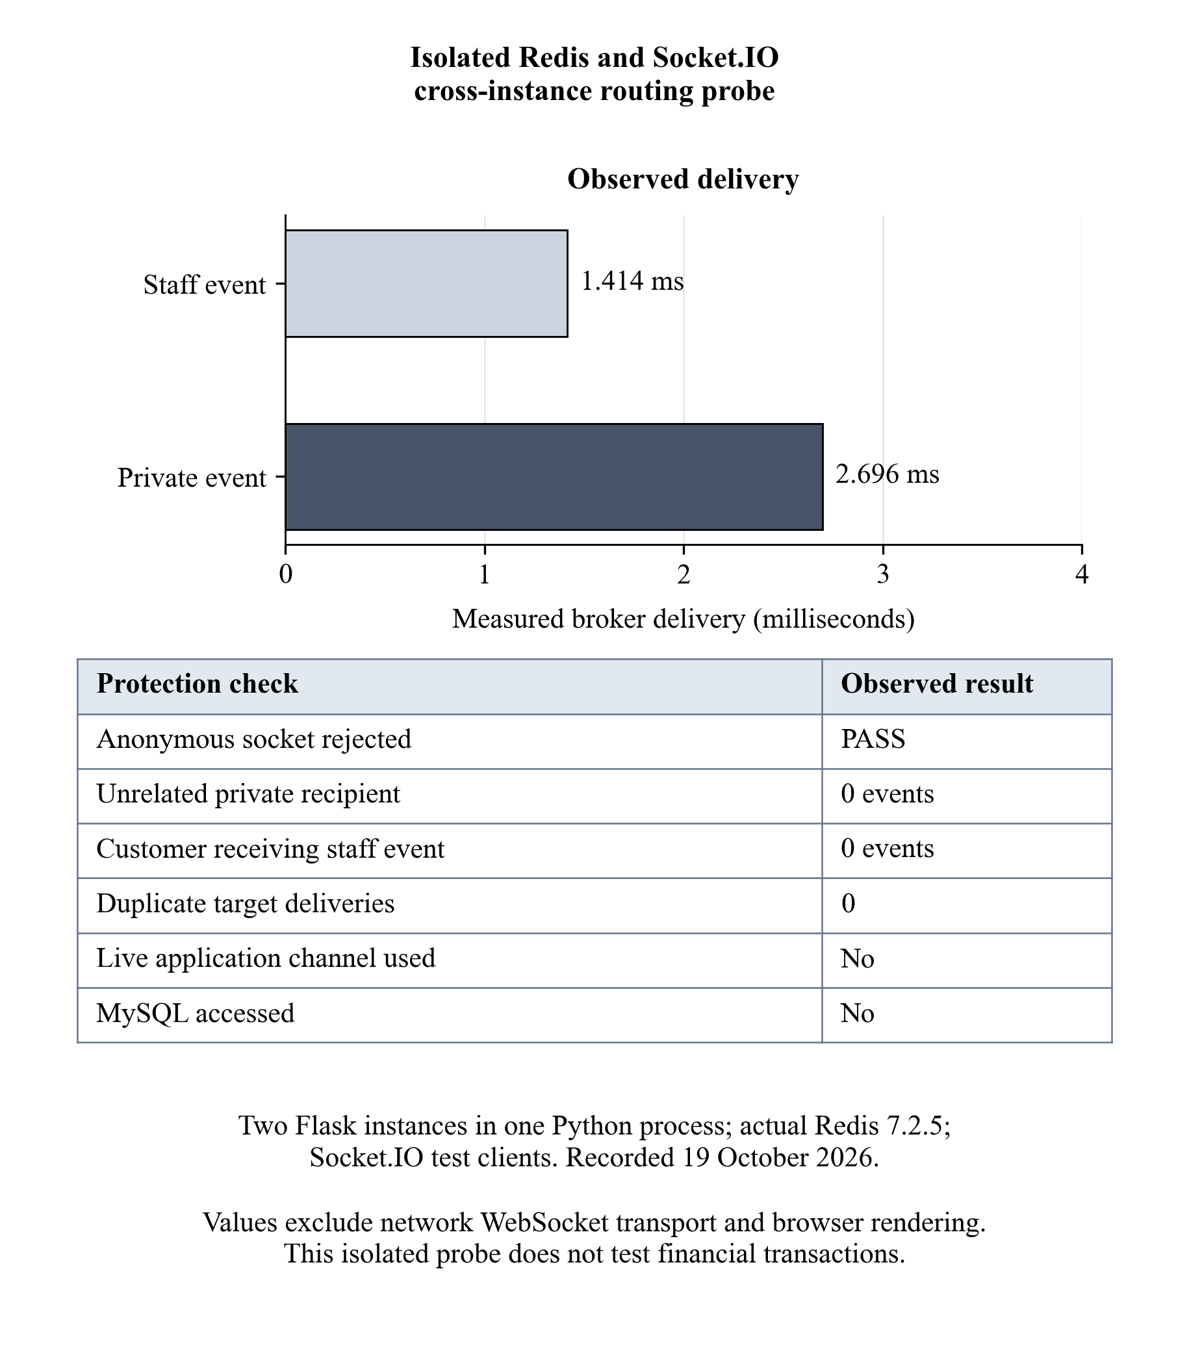
Figure 4.7: Isolated Redis and Socket.IO cross-instance routing probe
Source: actual administrator model-settings interface, rendered read-only on 19 October 2026. The displayed configuration applies to new decisions; historical scores were not recalculated.
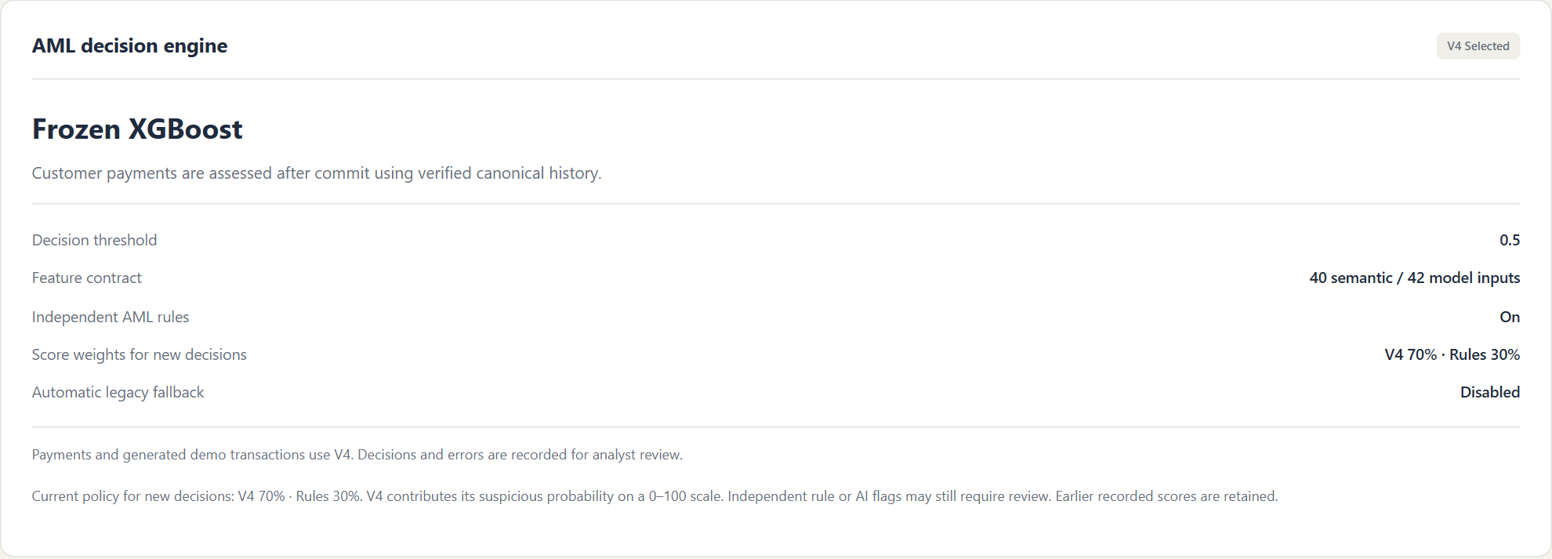
Figure 4.8: Configured risk-scoring weights for new decisions
The Redis 7.2.5 probe recorded private/staff delivery in 0.002696/0.001414 seconds, with no duplicate or unauthorised delivery. It used a private channel, two Flask objects in one process and Socket.IO test clients. These timings established isolated broker routing, not two-process WebSocket/browser latency; panel timing remained unmeasured.

4.4.6 Financial Failure, Recovery and Concurrency Procedure
Disposable failure tests separated pre-commit rollback from post-commit analysis failure. After commit, balances, payment identity, captures and rule evidence remained intact; retry appended audit evidence without another transfer. Payment counts and wallet reconciliation verified that distinction.
Verification and inference required matching source revisions. Concurrent changes caused closed failure or bounded repetition of nonfinancial work. A controlled transfer demonstration still required one request/transaction identity, exact before/after balances, matching captures and a stored result or explicit error.

4.4.7 Workflow Coverage and Remaining Verification Boundaries
Linked workflow checks followed the same payment from customer history to compliance review and retained communication. Staff, wallet and message events used authorised rooms; reconnecting clients recovered stored state. Recorded checks did not cover every network interruption or operating-system background condition.

4.4.8 Recorded Functional Checks and Verification Status
Table 4.12 records 54 frozen-inference passes, 30 feature-fixture passes and 38 separate scoring-review passes. Reused cases overlapped, so these totals were not combined. Chapter preparation added saved-array recomputation, not live financial tests.
Table 4.12: Recorded model-service and application verification coverage
Check / identifier | Expected result | Actual retained evidence | Status and scope
M01: test_preload_rejections | Reject wrong path/hash/runtime | Recorded rejections passed before deserialisation | PASS; retained isolated suite
M02: test_saved_parity | Load frozen pipeline; keep 42-column order and probability parity | 64 Train and 64 Validation rows matched exactly; maximum probability difference 0 | PASS; retained development parity
M03: test_threshold | Normal below 0.50; suspicious at and above 0.50 | All three boundary decisions passed | PASS; retained isolated suite
M04: test_schema_nan_and_sentinels | Reject malformed schema; handle declared markers safely | Schema, sentinel and ordered-column checks passed | PASS; retained isolated suite
M05: test_history_failures_no_model | Reject unknown, incomplete or stale history | No model call on rejected histories; no fabricated prediction | PASS; retained isolated suite
M06: test_model_error_never_normal | Retain explicit error for model failure | Invalid estimator output and resource-exhaustion handling passed | PASS; retained isolated suite
A01: scoring/retry suites | 70% probability-risk / 30% rule score; preserve case and payment | 38 focused nonfinancial checks passed, including error and audited retry handling | PASS; 19 October offline review
A02: disposable transfer / cash-in | One committed identity and canonical captures; separate rule alert | Historical records showed transfer 6 and cash-in 7; both model-normal, cash-in had a rule alert | Observed cases; complete suite not claimed
A03: disposable error/retry | Retain payment and original error; retry analysis only | Transaction 8 retry succeeded; financial/capture hashes and original error preserved | PASS for recorded recovery
A04: Cash-Out completeness | Commit and reconcile Cash-Out with its linked V4 result | Code/fixture coverage retained; no full live Cash-Out acceptance record in this evidence set | NOT FULLY VERIFIED
A05: page and role review | Load authorised routes; reject private/staff access by other roles | 18 sampled route/viewport cases passed; no content fingerprint change | PASS for sampled read-only cases
A06: stored history and review | Same customer transaction and alert visible with separate findings | Transaction 15222 / wallet ACC1011 and alert 6900 rendered from stored records | PASS for retrieval; no new outcome submitted
A07: private messaging | Retain thread; distinguish sent, delivered and read | Stored conversation screenshots and targeted receipt tests supported the implementation | PARTIALLY VERIFIED; timed pair exchange unmeasured
A08: isolated Redis routing | Deliver only to authorised target, without duplicates | Private/staff delivery received; unrelated/customer/anonymous paths excluded | PASS for one-process broker probe
T01: two-instance panel timing | Visible authorised update within five seconds | No measured two-process network/browser panel result retained | NOT MEASURED

Disposable transfer, cash-in and retry observations supported those cases only; full Cash-Out and end-to-end acceptance remained incomplete. Internal case reports were not regulatory submissions.

4.5 Evaluation Against the Five SMART Objectives
Table 4.13: Objective evidence and remaining panel acceptance measurements
Objective and deadline | Recorded functional evidence | Required timed panel demonstration
1. Transaction generation module; week 4 | History-aware planner, canonical capture and payment controls implemented | Save 10 valid events: 7 routine and 3 suspicious scenarios within 3 minutes; reconcile wallets and IDs
2. Redis/WebSocket real-time engine; week 8 | Private broker routing and staff-room isolation checked | Deliver one authorised update across two instances within 5 seconds; exclude unauthorised sessions
3. Compliance dashboard; week 9 | Alert detail, separate findings and authorised review path available | Review a flagged transaction and record an investigation outcome within 2 minutes
4. Trained-model and rules risk assessment; week 10 | Frozen training/evaluation evidence, V4 selection and history gate retained | Show assessment for one committed payment within 30 seconds, with separate AI/rule findings
5. Professional messaging; week 11 | Stored messages and sent/delivered/read transitions verified in targeted tests | Persist a message and reply within 2 minutes per authorised pair: Customer–Compliance and Compliance–Admin
Table 4.13 links the five unchanged Chapter 1 objectives to evidence and remaining timed demonstrations. All were implemented and partially verified, but their full panel execution times were not recorded.

4.5.1 Transaction Generation Objective
The planner and payment controls supported the generation workflow. A reconciled ten-event batch with seven routine and three suspicious intentions, saved within three minutes, remained unmeasured; the screenshot showed planning only.

4.5.2 Cross-Instance Real-Time Objective
The isolated probe verified authorised broker routing. Two independently running instances delivering a visible update within five seconds remained unmeasured; staff/private access restrictions were mandatory.

4.5.3 Compliance Review Objective
Stored alerts, separate findings and access controls supported review. A two-minute task ending in a newly persisted investigation outcome remained unmeasured; historical missing reasoning could not be manufactured.

4.5.4 Model and Rules Risk-Assessment Objective
Frozen training/validation evidence and nonfinancial primary/retry checks supported assessment. A committed payment with fresh history, separate model/rule findings and completion within thirty seconds remained unmeasured. Independent unseen model testing was also outstanding.

4.5.5 Professional Messaging Objective
Stored threads and receipt tests supported messaging. A message-and-reply exchange within two minutes for each Customer-Compliance and Compliance-Administrator pair remained unmeasured. Closed-browser push was not established.

4.6 Discussion in Relation to Previous Work
Whisker and Lokanan [8] provided the mobile-money threat context. This application connected transaction histories and account relationships to investigation, but the literature did not validate its classifier or establish that a local alert represented laundering.
The AML evaluation concerns discussed by Jensen and Iosifidis [3] were reflected in sparse S2/S4 support and validation reuse despite high aggregate macro F1. Family denominators and missed examples therefore offered more useful interpretation than accuracy alone.
Tertychnyi et al. [15] offered relevant time-aware monitoring context. This system used causally available history, a frozen tabular classifier and post-commit analysis. Without common data, hardware and timing protocols, comparative accuracy or latency superiority could not be established.
Like the synthetic-data research of Altman et al. [16], the benchmark enabled controlled, repeatable evaluation. Its assumptions were not calibrated to an operational Zimbabwean provider, so matching scenario labels did not measure real financial-crime detection.
Jullum et al. [6] supported the decision-support role of machine learning in investigation prioritisation. Ndlovu et al. [11] provided local graph-based research context. The present system retained officer review and encoded network history into tabular features; it did not compare a graph model on the same benchmark.
The technical contribution integrated history-aware generation, causal classification, separate rule findings, payment safety, compliance review and authorised communication. The empirical contribution was a reproducible development comparison with documented family weaknesses. Scenario labels were established independently of predictions, scores and officer outcomes. Entity separation reduced leakage, but validation reuse and constructed labels limited claims of independent generalisation, novelty and operational effectiveness.
Table 4.14: Comparison with reviewed approaches and limits of comparison
Reviewed work | Relevant comparison | Boundary of the present evidence
Jensen and Iosifidis [3] | Multiple metrics, imbalance and evaluation validity | Synthetic reused validation; no operational precision estimate
Tertychnyi et al. [15] | Time-aware monitoring and interpretable evidence | Different representation and deployment; no matched latency experiment
Altman et al. [16] | Controlled synthetic AML evaluation | Constructed scenarios; no real-provider transportability claim
Jullum et al. [6] | Machine-learning-assisted manual prioritisation | Officer review retained; no measured investigation-efficiency advantage
Ndlovu et al. [11] | Relational AML research in Zimbabwe | No same-data graph-versus-tabular benchmark

4.7 Limitations of the Results
Limitations included synthetic external validity, unequal family supports, repeated validation reuse and incomplete panel timing. Only three validation communities limited observational independence. A union prediction could not identify the cause of overlapping family behaviour.
Missed-positive rates were 9.64% overall, 52.17% for S2 and 75% for S4; normal false-positive rate was 0.99%. These denominators differed from operational alert ratios. Rules, transaction mix and repeated-account activity could change review workload.
There was no live operator, telecommunications, regulator or external identity-service connection, and no measured reduction in laundering loss or investigator effort. Representative independent evaluation, drift monitoring and complete workflow timing were still required.
Page, socket and disposable-ledger tests did not establish sustained production capacity, universal mobile-notification behaviour or regulatory suitability.

4.8 Summary
Frozen V4 achieved macro F1 0.956670, suspicious recall 0.903630 and false-positive rate 0.009858 on 15,000 reused synthetic validation observations. Family diagnostics exposed S2/S4 weaknesses, and the exploratory representation did not replace the retained pipeline. Functional evidence supported specific payment, review, messaging and broker paths. All five objectives remained partially verified against full panel timing; separate unseen testing and operational effectiveness were outstanding. Chapter 5 presents conclusions and recommendations.

